Slot Reel Design

LInk: https://docs.google.com/document/d/1g3gRfZ9eHyUUzFHqDlLqZCaUm_qizc8T6N6OT2XDKoY/edit?usp=sharing

Reel 1
Symbols | Frequency
 | 5
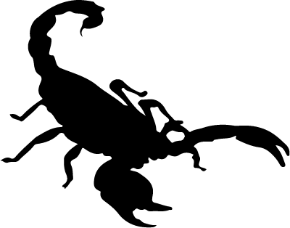 | 4
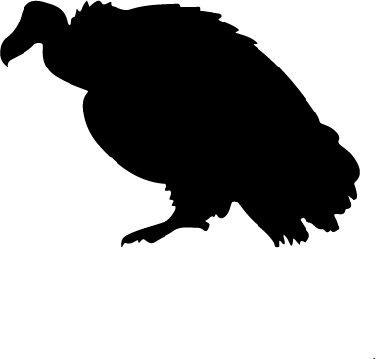 | 3
 | 2
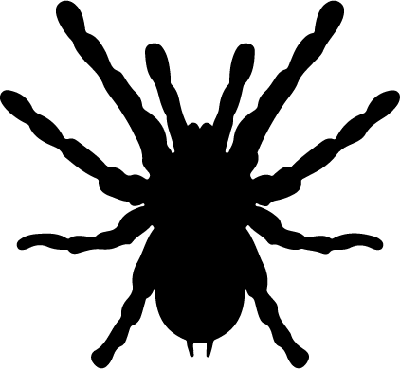 | 1
 | 4
 | 2
 | 2
 | 1
 | 1

Reel 2
Symbols | Frequency
 | 3
 | 2
 | 1
 | 5
 | 4
 | 1
 | 4
 | 2
 | 2
 | 1

Reel 3
Symbols | Frequency
 | 1
 | 1
 | 1
 | 1
 | 1
 | 5
 | 5
 | 3
 | 3
 | 4

Reel 4
Symbols | Frequency
 | 4
 | 5
 | 1
 | 2
 | 3
 | 1
 | 1
 | 4
 | 2
 | 2

Reel 5
Symbols | Frequency
 | 1
 | 2
 | 3
 | 4
 | 5
 | 2
 | 1
 | 1
 | 4
 | 2

Payout Matrix

Show your Payout Matrix here. Show all of the winning combinations and what you will pay for them. Add or remove rows as needed.

Winning Combination | Payout
 | 25
 | 100
 | 50
 | 50
 | 100
 | 500
 | 500
 | 200
 | 200
 | 1000

Return Calculations

Show all of your calculations for the returns. Add them all up to show the Payout Rate of your system. Clearly mark your progressive and bonus game calculations.
Calculations 1

 | Chance to Hit REEL 1 | Chance to Hit  REEL 2 | Chance to Hit  REEL 3 | Chance to Hit  REEL 4 | Chance to Hit  REEL 5
Payout 1 | 5/25 = 0.2 | 2/25 =0.08 | 1/25 = 0.04 | 2/25 =0.08 | 5/25 = 0.2
Payout 2 | 1/25 = 0.04 | 3/25 = 0.12 | 1/25 = 0.04 | 1/25 = 0.04 | 4/25 = 0.16
Payout 3 | 2/25 =0.08 | 4/25 = 0.16 | 1/25 = 0.04 | 5/25 = 0.2 | 3/25 = 0.12
Payout 4 | 3/25 = 0.12 | 5/25 = 0.2 | 1/25 = 0.04 | 4/25 = 0.16 | 2/25 =0.08
Payout 5 | 4/25 = 0.16 | 1/25 = 0.04 | 1/25 = 0.04 | 3/25 = 0.12 | 1/25 = 0.04
Payout 6 | 4/25 = 0.16 | 1/25 = 0.04 | 5/25 = 0.2 | 1/25 = 0.04 | 2/25 =0.08
Payout 7 | 2/25 =0.08 | 4/25 = 0.16 | 5/25 = 0.2 | 1/25 = 0.04 | 1/25 = 0.04
Payout 8 | 2/25 =0.08 | 2/25 =0.08 | 3/25 = 0.12 | 4/25 = 0.16 | 1/25 = 0.04
Payout 9 | 1/25 = 0.04 | 2/25 =0.08 | 3/25 = 0.12 | 2/25 =0.08 | 4/25 = 0.16
Payout 10 | 1/25 = 0.04 | 1/25 = 0.04 | 4/25 = 0.16 | 2/25 =0.08 | 2/25 =0.08

Calculations 2

 | Chance to Hit Calc
Payout 1 | (.2) * (.08) * (.04) * (.08) * (.2) = 0.00001024
Payout 2 | (.04) * (.12) * (.04) * (.04) * (.16) = 0.0000012288
Payout 3 | (.08) * (.16) * (.04) * (.2) * (.12) = 0.000012288
Payout 4 | (.12) * (.2) * (.04) * (.16) * (.08) = 0.000012288
Payout 5 | (.16) * (.04) * (.04) * (.12) * (.04) = 0.0000012288
Payout 6 | (.16) * (.04) * (.2) * (.04) * (.08) = 0.000004096
Payout 7 | (.08) * (.016) * (.2) * (.04) * (.04) = 0.000004096
Payout 8 | (.08) * (.08) * (.12) * (.16) * (.04) = 0.0000049152
Payout 9 | (.04) * (.08) * (.12) * (.08) * (.16) = 0.0000049152
Payout 10 | (.04) * (.04) * (.16) * (.08) * (.08) = 0.0000016384

Calculations 3

 | Unmodified Payout
Payout 1 | 1 * 0.00001024 = 0.00001024
Payout 2 | 1 * 0.0000012288 = 0.0000012288
Payout 3 | 1 * 0.000012288 = 0.000012288
Payout 4 | 1 * 0.000012288 = 0.000012288
Payout 5 | 1 * 0.0000012288 = 0.0000012288
Payout 6 | 1 * 0.000004096 = 0.000004096
Payout 7 | 1 * 0.000004096 = 0.000004096
Payout 8 | 1 * 0.0000049152 = 0.0000049152
Payout 9 | 1 * 0.0000049152 = 0.0000049152
Payout 10 | 1 * 0.0000016384 = 0.0000016384

Calculations 4

 | Show Payout
Payout 1 | 2 * 0.00001024 * 0.95 = 0.000019456
Payout 2 | 2 * 0.0000012288 * 0.95 = 0.00000233472
Payout 3 | 2 * 0.000012288 * 0.95 = 0.000023332
Payout 4 | 2 * 0.000012288 * 0.95 = 0.0000233472
Payout 5 | 2 * 0.0000012288 * 0.95 = 0.00000233472
Payout 6 | 3 * 0.000004096 * 0.85 = 0.0000104448
Payout 7 | 3 * 0.000004096 * 0.85 = 0.0000104448
Payout 8 | 3 * 0.0000049152 * 0.85 = 0.00001253376
Payout 9 | 3 * 0.0000049152 * 0.85 = 0.00001253376
Payout 10 | 3 * 0.0000016384 * 0.85 = 0.00000417792

Calculations 5

 | Symbols | Cost | Payout % | PAYOUT | Unmodified PAYOUT | Chance to HIT
Payout 1 |  | 2 | 0.95 | 0.00001024 | 0.00002048 | 0.000019456
Payout 2 |  | 2 | 0.95 | 0.000012288 | 0.0000024576 | 0.00000233472
Payout 3 |  | 2 | 0.95 | 0.000012288 | 0.00002456 | 0.000023332
Payout 4 |  | 2 | 0.95 | 0.000012288 | 0.000024576 | 0.0000233472
Payout 5 |  | 2 | 0.95 | 0.0000012288 | 0.000012288 | 0.00000233472
Payout 6 |  | 3 | 0.85 | 0.000004096 | 0.000012288 | 0.0000104448
Payout 7 |  | 3 | 0.85 | 0.000004096 | 0.000012288 | 0.0000104448
Payout 8 |  | 3 | 0.85 | 0.0000049152 | 0.0000147456 | 0.00001253376
Payout 9 |  | 3 | 0.85 | 0.0000049152 | 0.0000147456 | 0.00001253376
Payout 10 |  | 3 | 0.85 | 0.0000016384 | 0.0000049152 | 0.00000417792

Progressive System

The progressive system for this machine is a dual static system that also the Bonus Game. As shown above the Critters side of player has a 2 dollar cost while the Trinkets have a 3 dollar cost. Notice the payout percentage is different for these two categories vs. the payout amount. This is how the two sides work. Players on the 2 dollar cost that get payouts 6 - 10 only build up the progressive pot displayed above the Trinket side display. Players on the 3 dollar cost that get payouts 1 - 5 only build up the progressive pot displayed above the Critter side display. This is to entice players to play that side of the payout where as they automatically get the payout for the side they are playing Critter or Trinket. The progressive system will take the following to add to the pot.

To win the progressive the player must play that side of the Critters or Trinkets where the payout is the normal winning plus the progressive pot total.

 | Winning divided by cost divided by Payout % | New Payout to be displayed
Payout 1 | 100 / 2 / .95 | 52.631578947368421052631578947368
Payout 2 | 50 / 2 / .95 | 26.315789473684210526315789473684
Payout 3 | 50 / 2 / .95 | 26.315789473684210526315789473684
Payout 4 | 100 / 2 / .95 | 52.631578947368421052631578947368
Payout 5 | 500 / 2 / .95 | 263.15789473684210526315789473684
Payout 6 | 500 / 3 / .85 | 196.0784313725490196078431372549
Payout 7 | 200 / 3 / .85 | 78.431372549019607843137254901961
Payout 8 | 200 / 3 / .85 | 78.431372549019607843137254901961
Payout 9 | 500 / 3 / .85 | 196.0784313725490196078431372549
Payout 10 | 1000 / 3 / .85 | 392.1568627450980392156862745098

